Meeting called to order: 7:02pm
Members present: Chairman Serotta, Barry Sloan, Steve Denes, Carl D’Antonio, Dot Wierzbicki, Jackie Elfers
Absent: Bob Conklin
Also Present: Dave Donovan-Attorney, Alexa Burchianti-Secretary, Al Fusco-Engineer
Next meeting of the Planning Board is scheduled for June 7, 2017. May 17, 2017 meeting is cancelled.
Board updates: Steve Denes this will be his last meeting. Have been on the board for 6.5 years now and he and his wife will be relocating to the Toronto area imminently. It’s where we were thinking of retiring anyway. Will be heading up a new department. Chairman: Just wanted to say thank you for all your service to the Town to the Planning Board. And Shary has spent an immense amount of time and many many hours in all the work you both have done. We wish you a lot of luck.
Sage Outdoor– Public Hearing
Doug Barthel Proposing to replace the billboards along Greycourt Rd. Not moving them, they are staying in the same location. They will NOT be digital. Just going to update with monopole mental structure instead of the wood ones. 4 billboards. 3 double faced and 1 single faced.
This was a referable 239 to OCDP.
OCDP Response:
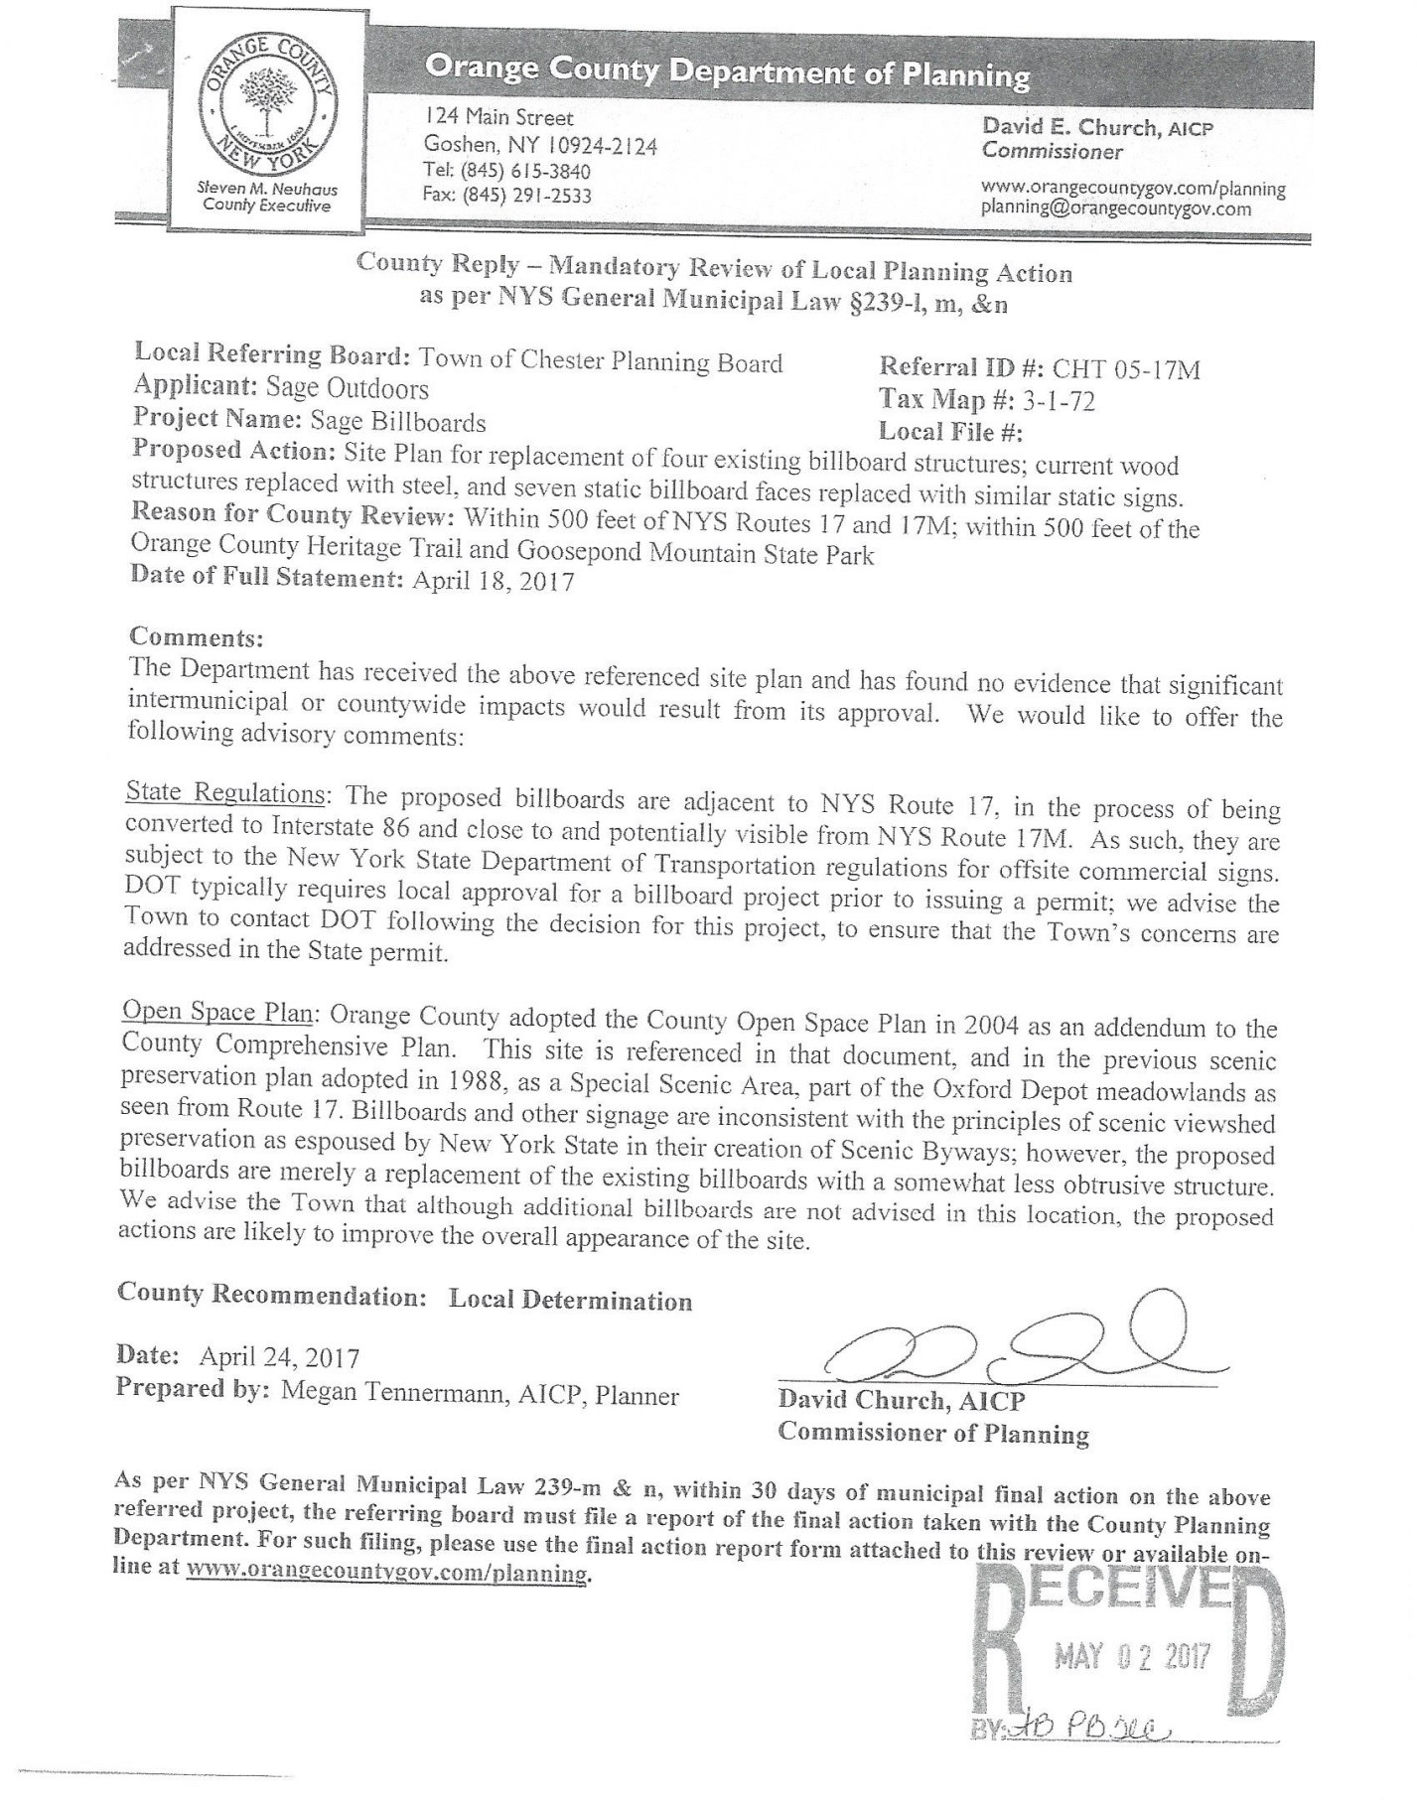

Al Fusco letter:
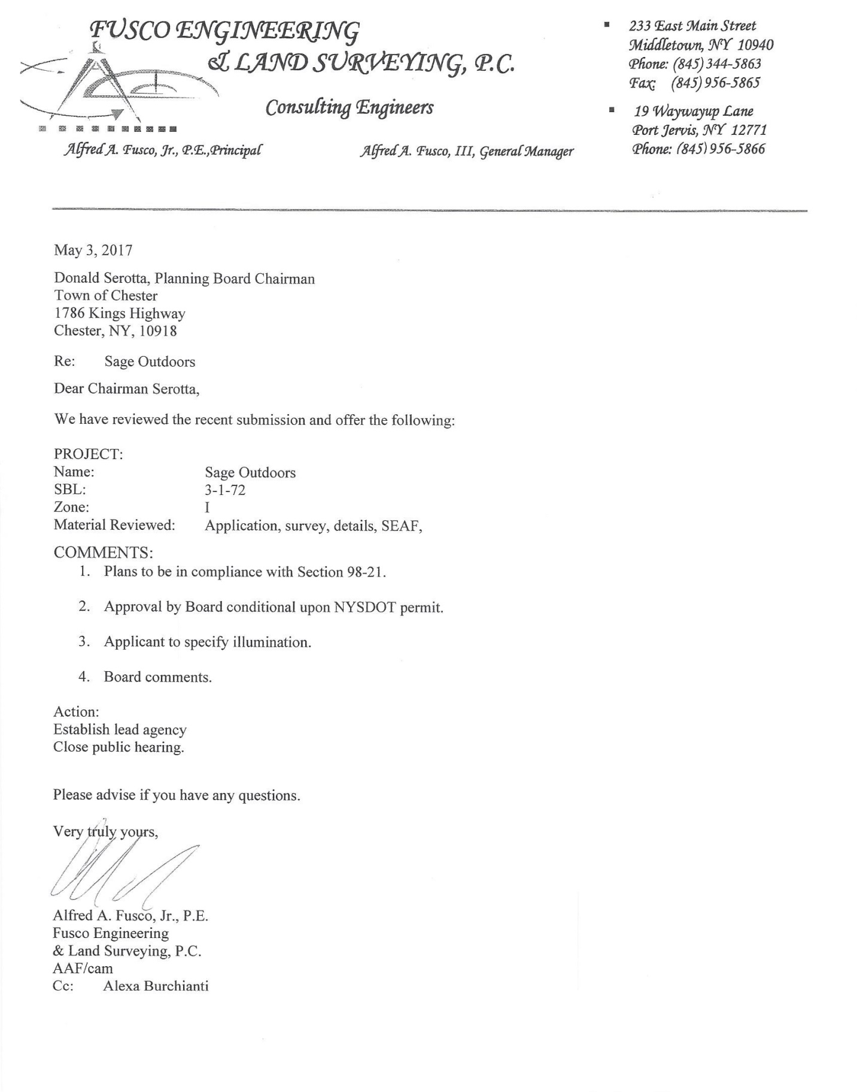
Al: Standard, the plans need to be in compliance with 98-21, conditional on NYS DOT, and need to forward the illuminations specs. The illumination is just low lighting.
Poll Board for comments or questions:
Carl: Lights go off at midnight? Doug: Yes
Let the record reflect that the proper mailings and legal notice was published in the Times Herald Record.
Tom Becker: Just a question, this is also in the I Zone, as well as the Lewis application. How does the I Zone effect this application? Doug: It won’t. Al: This is a strict replacement, on yours you were going digital and moving the locations. If you were to come back to us with them going in the exact same spot without digital we can amend the applications.
Clif Patrick: 2 questions. Are these replacements signs going to be the exact same size and same height? Doug: No, they will be a little bit bigger, most of them are going to be exactly the same size, the majority of the sign faces are 14x48 a couple are 14x42 and 14x44, the height code allows 35 feet. I wasn’t going above that, so it would be within the building code. Clif: the 2nd question is, you said lights are pointing up? Doug: Yes, they are very low dispersion lighting so they just hit the sign face so you don’t get the spillage like you have on the signs now.
Barry: Al, what’s the max sq footage per sign. Al: I will look it up I believe it’s 14x48. Which is 672 square feet. Barry: Ok
Let the record reflect that no one else spoke for or against the application.
Motion to close public hearing. Motion made by Dot. Second by Jackie. Motion carried 5-1 Barry opposed.
Motion made to grant Negative Declaration. Motion made by Steve. Second by Dot. Motion carried 5-1 Barry opposed.

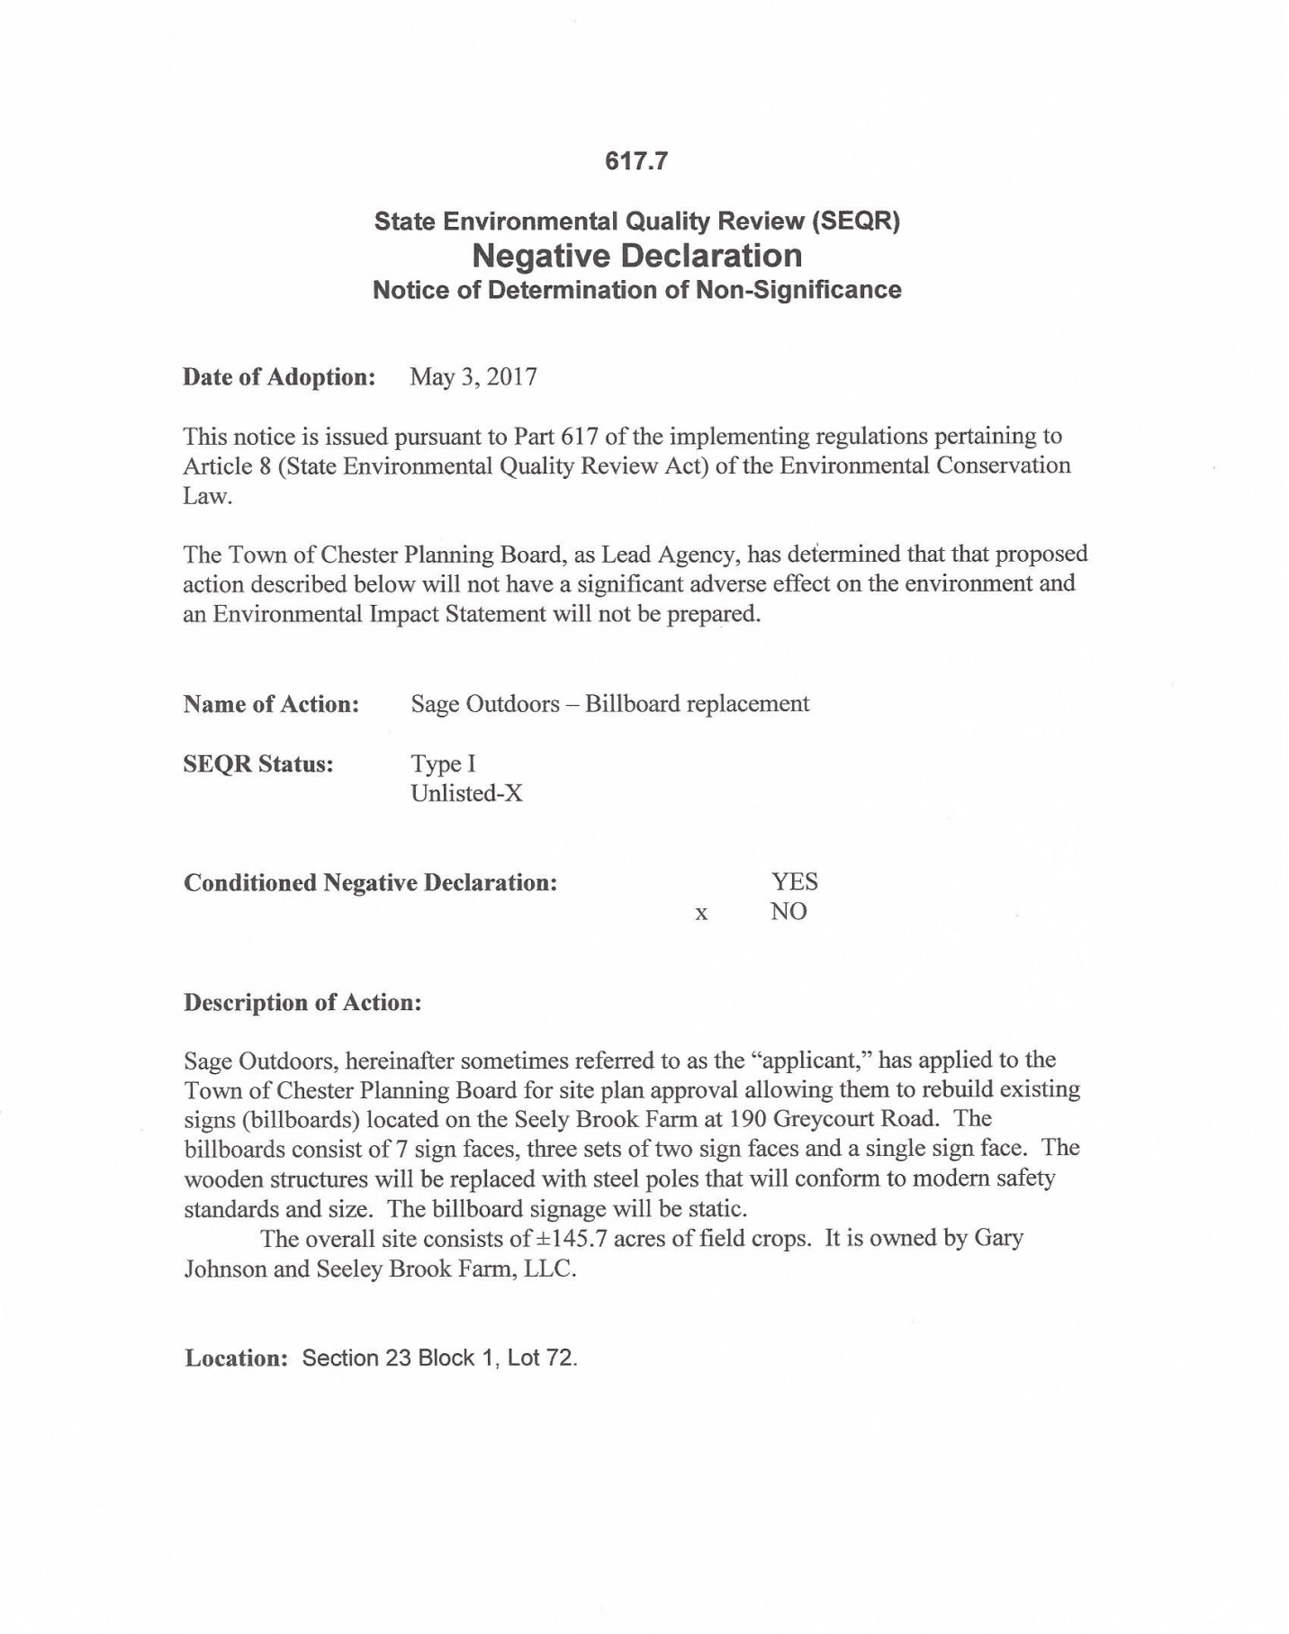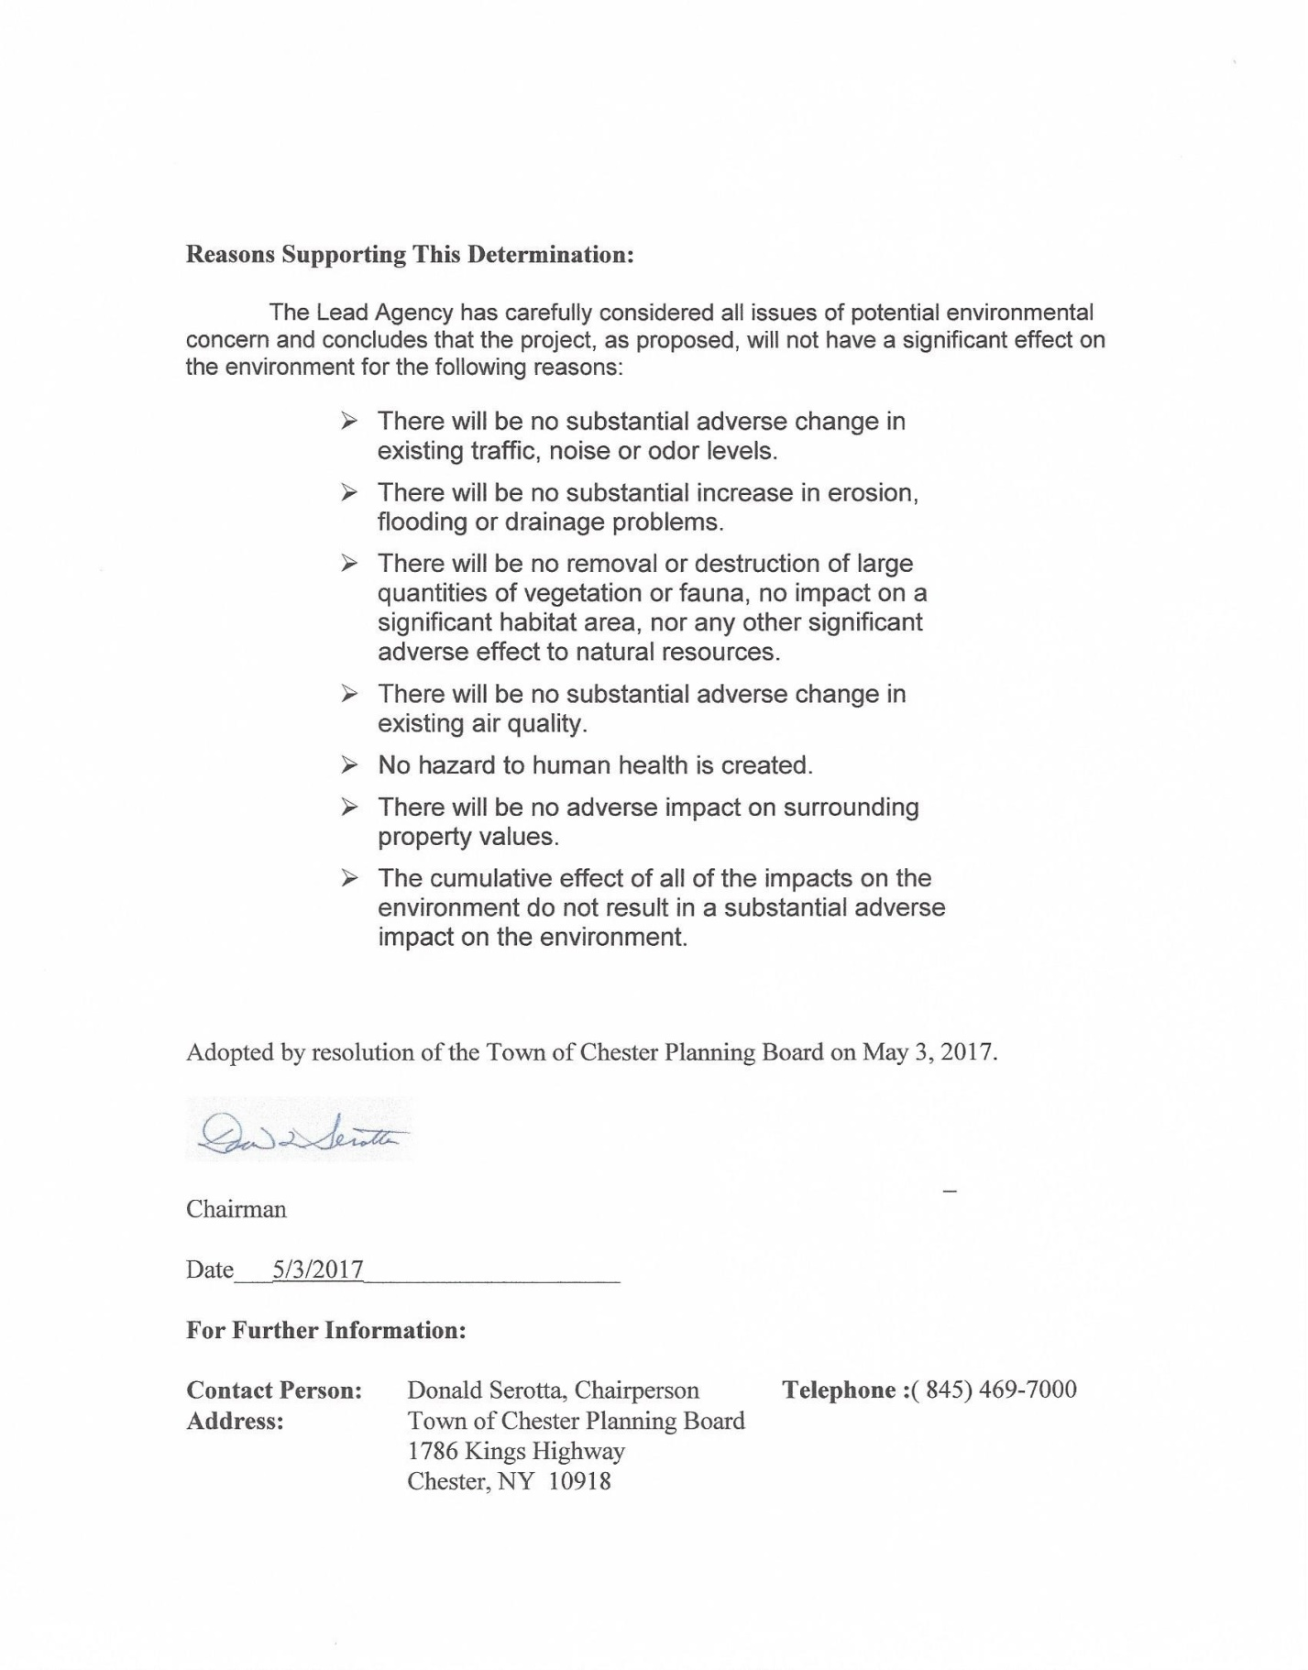
Motion made to grant Conditional Final Approval. Motion made by Jackie. Second by Carl. Motion carried. 5-1 Barry opposed.
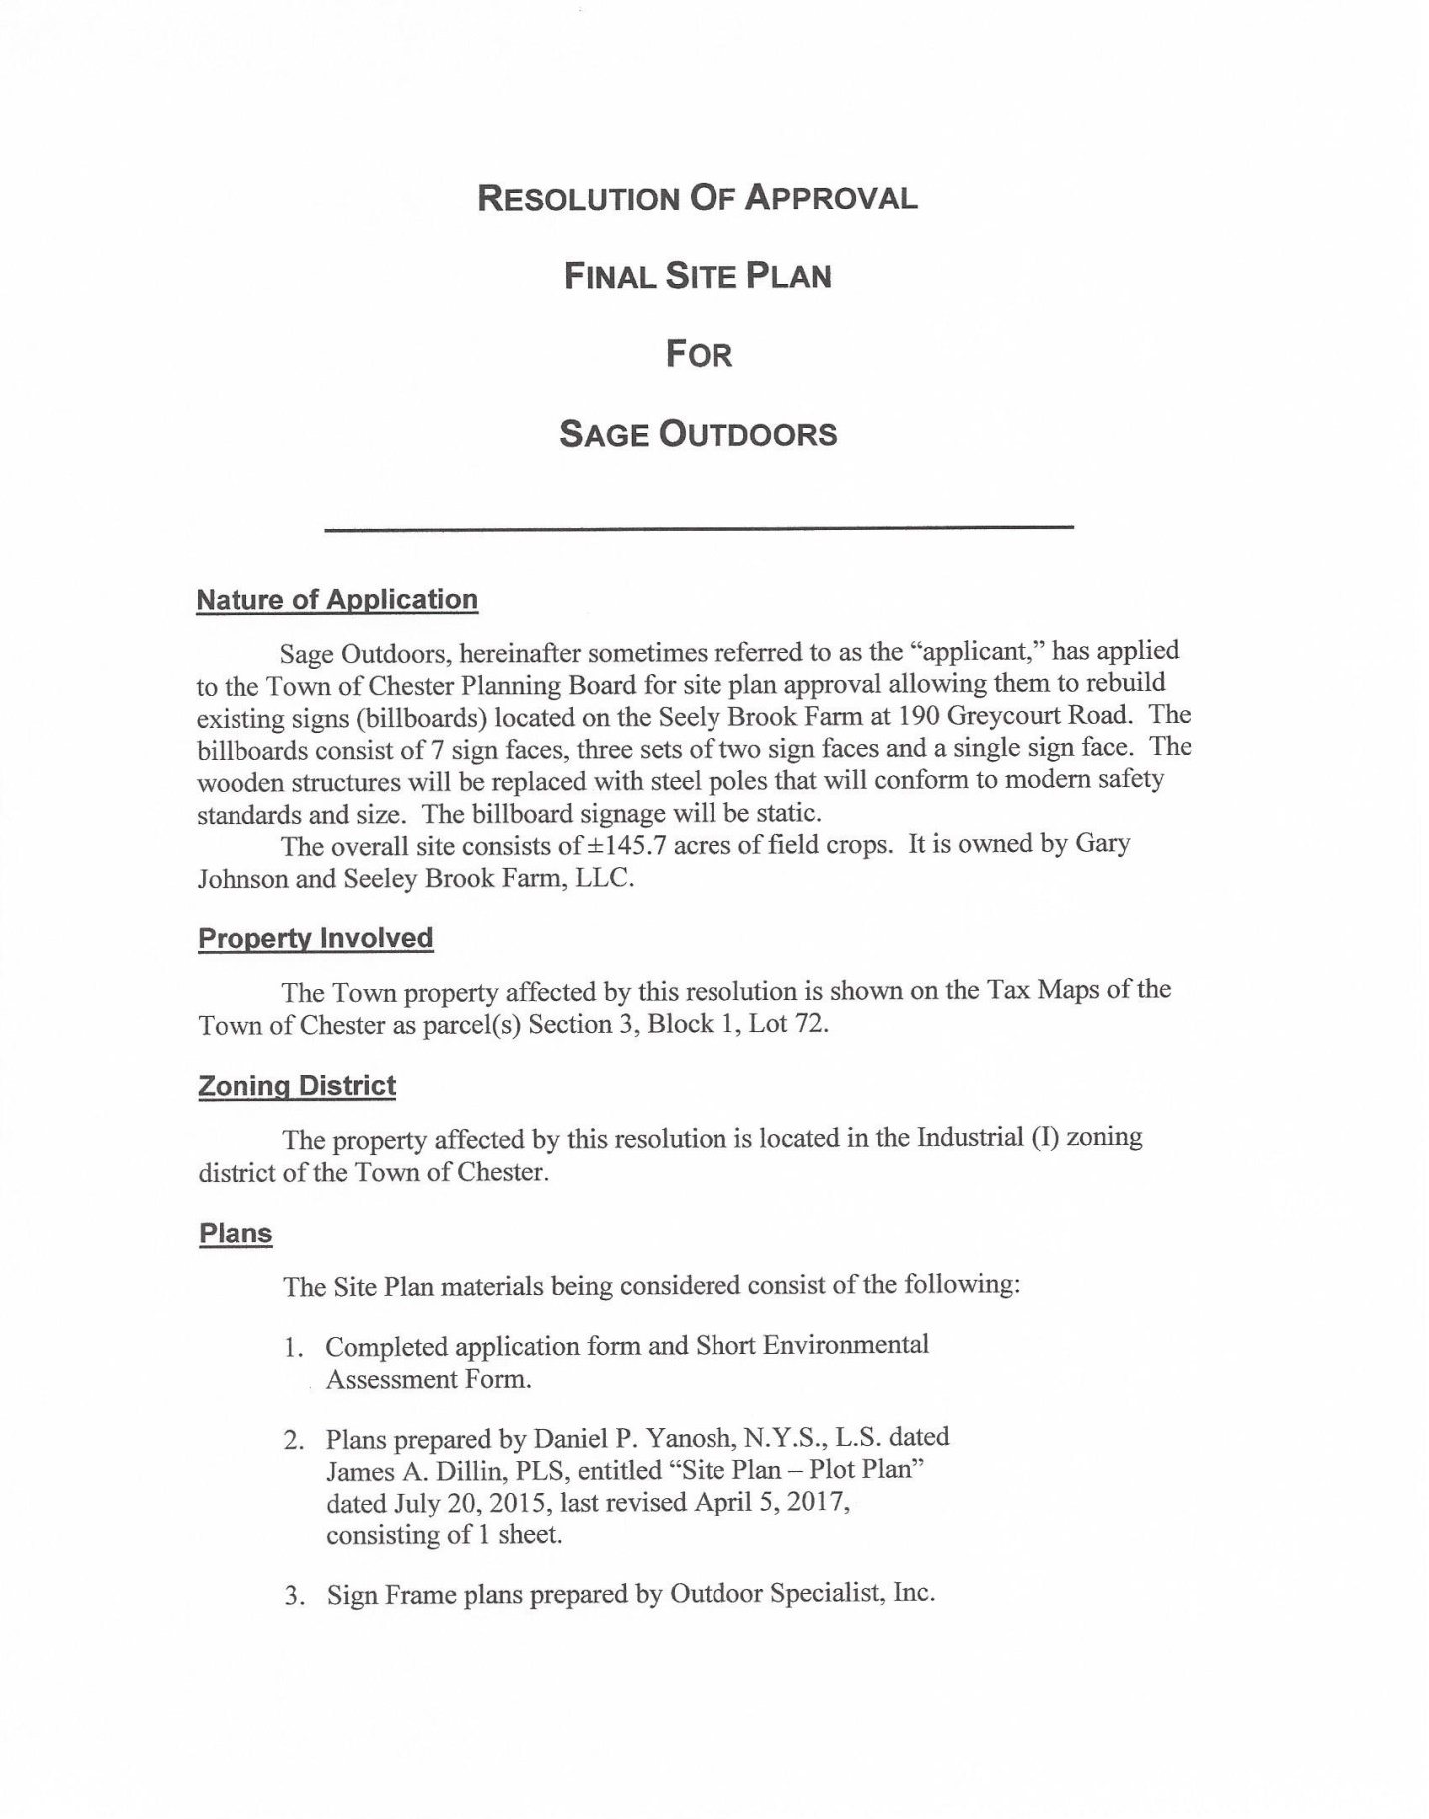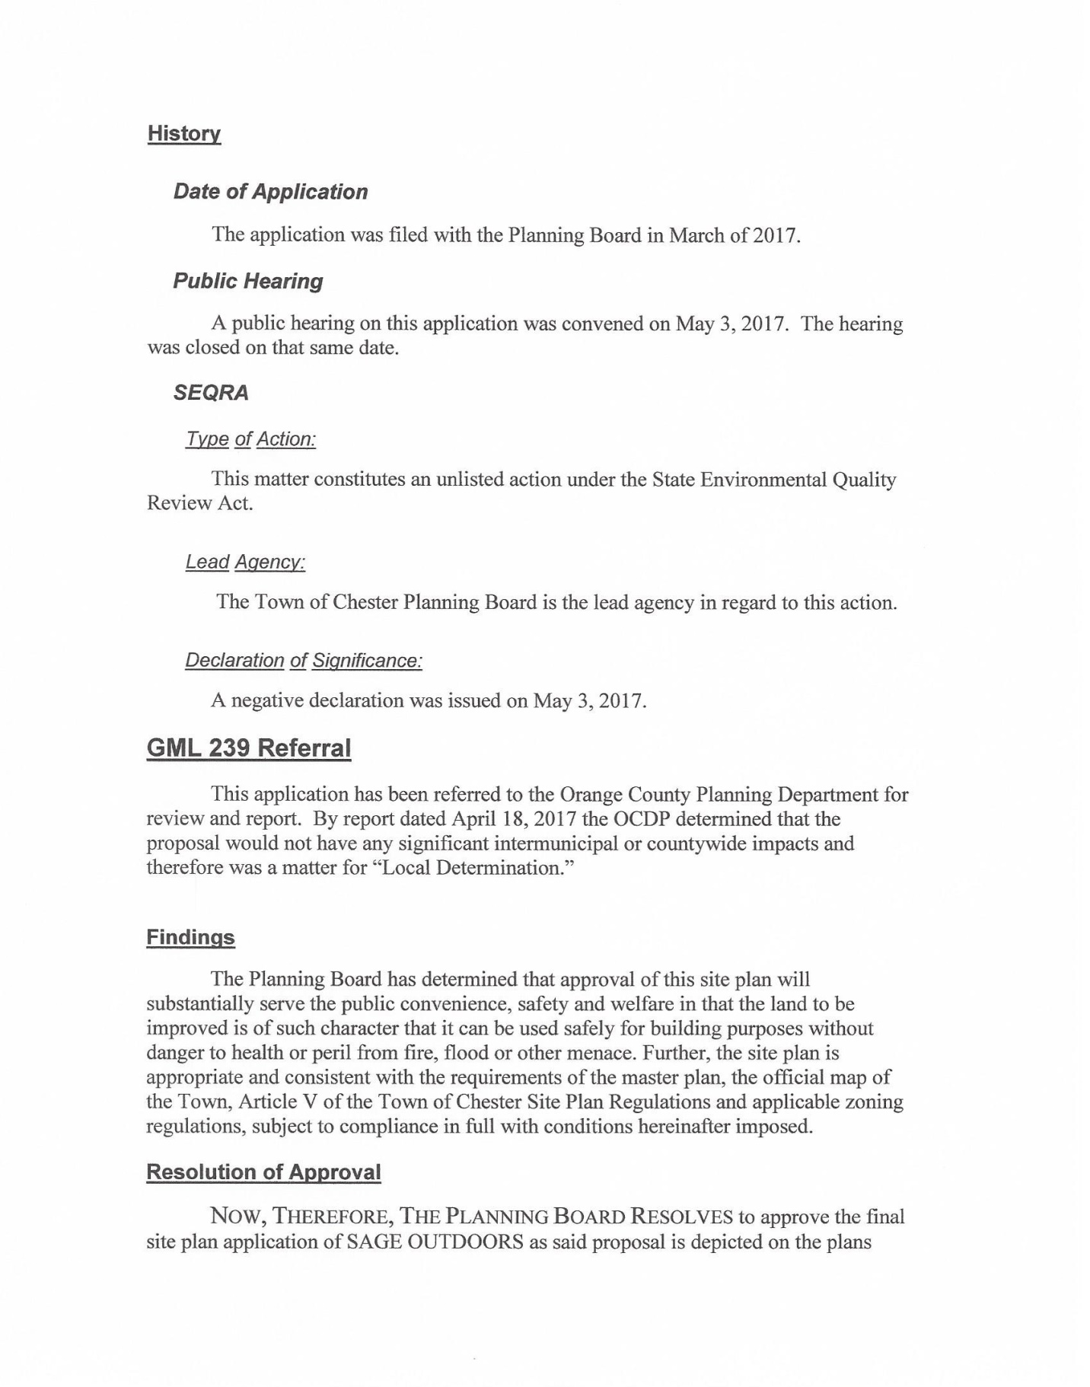
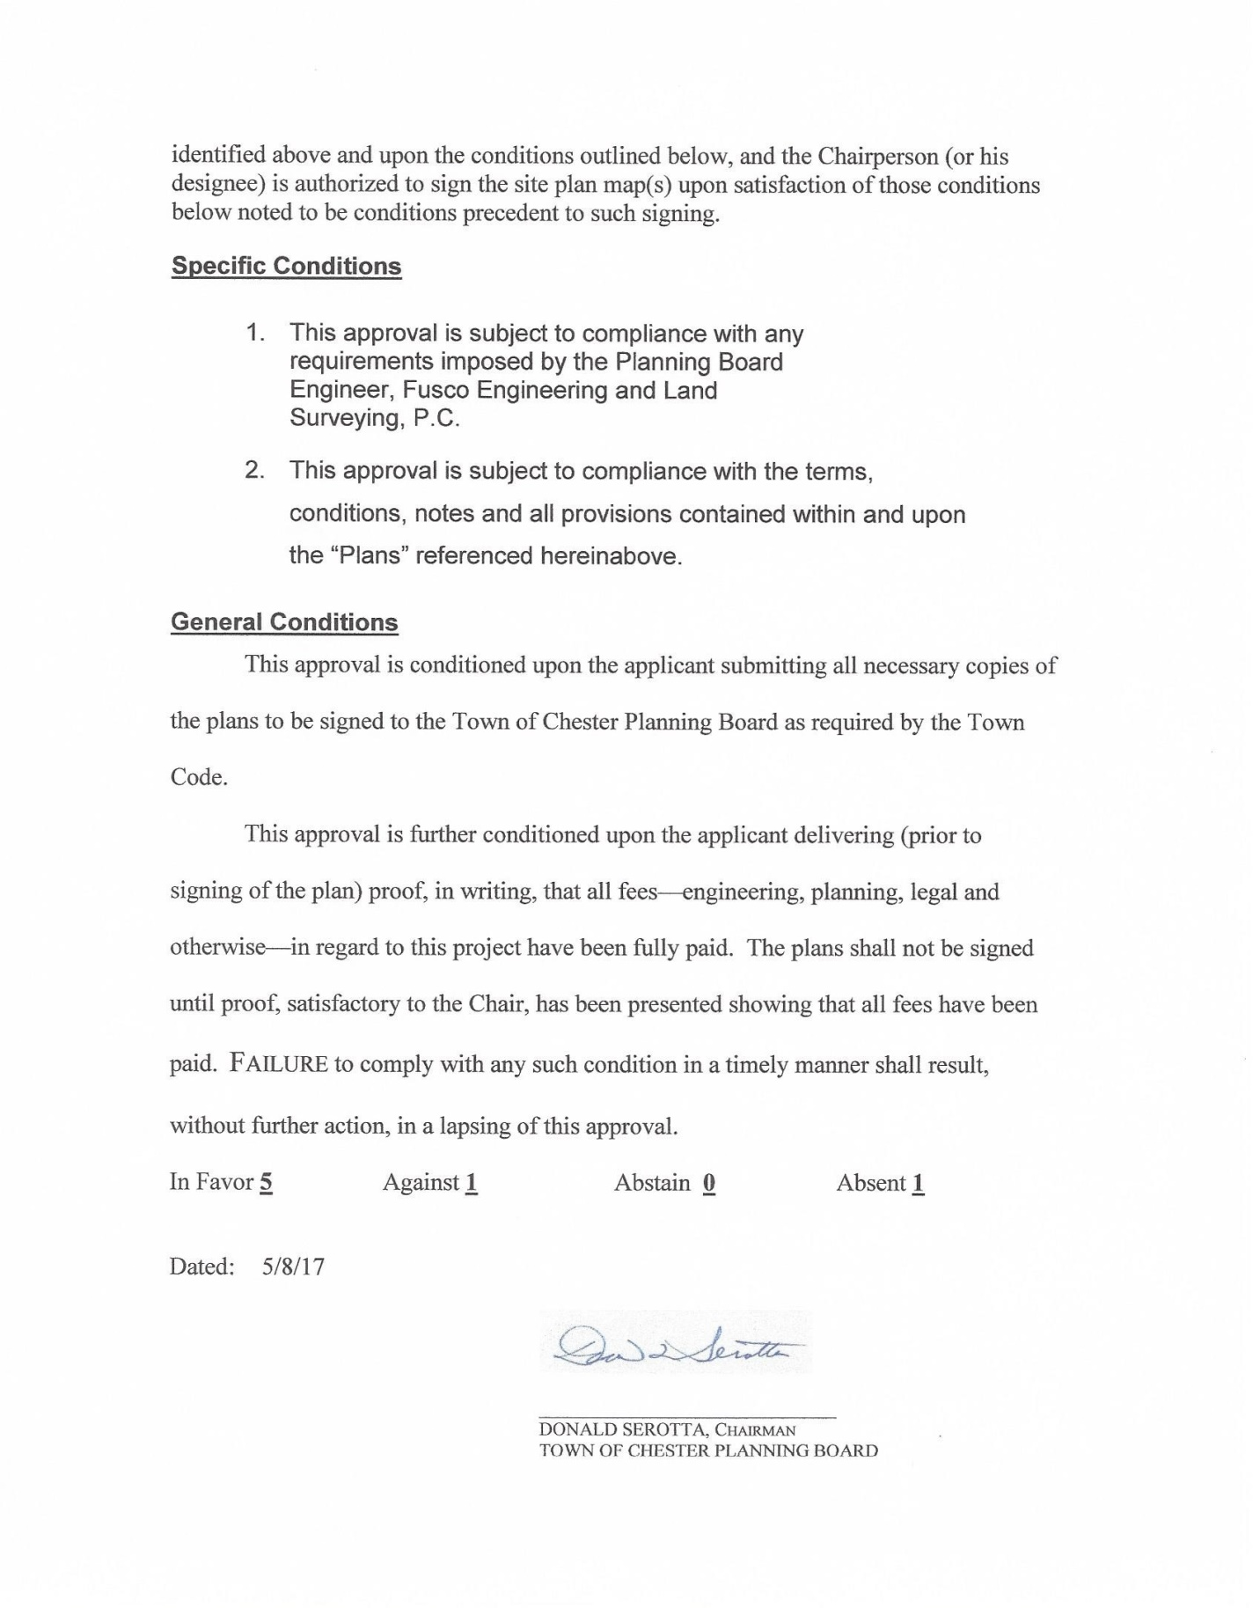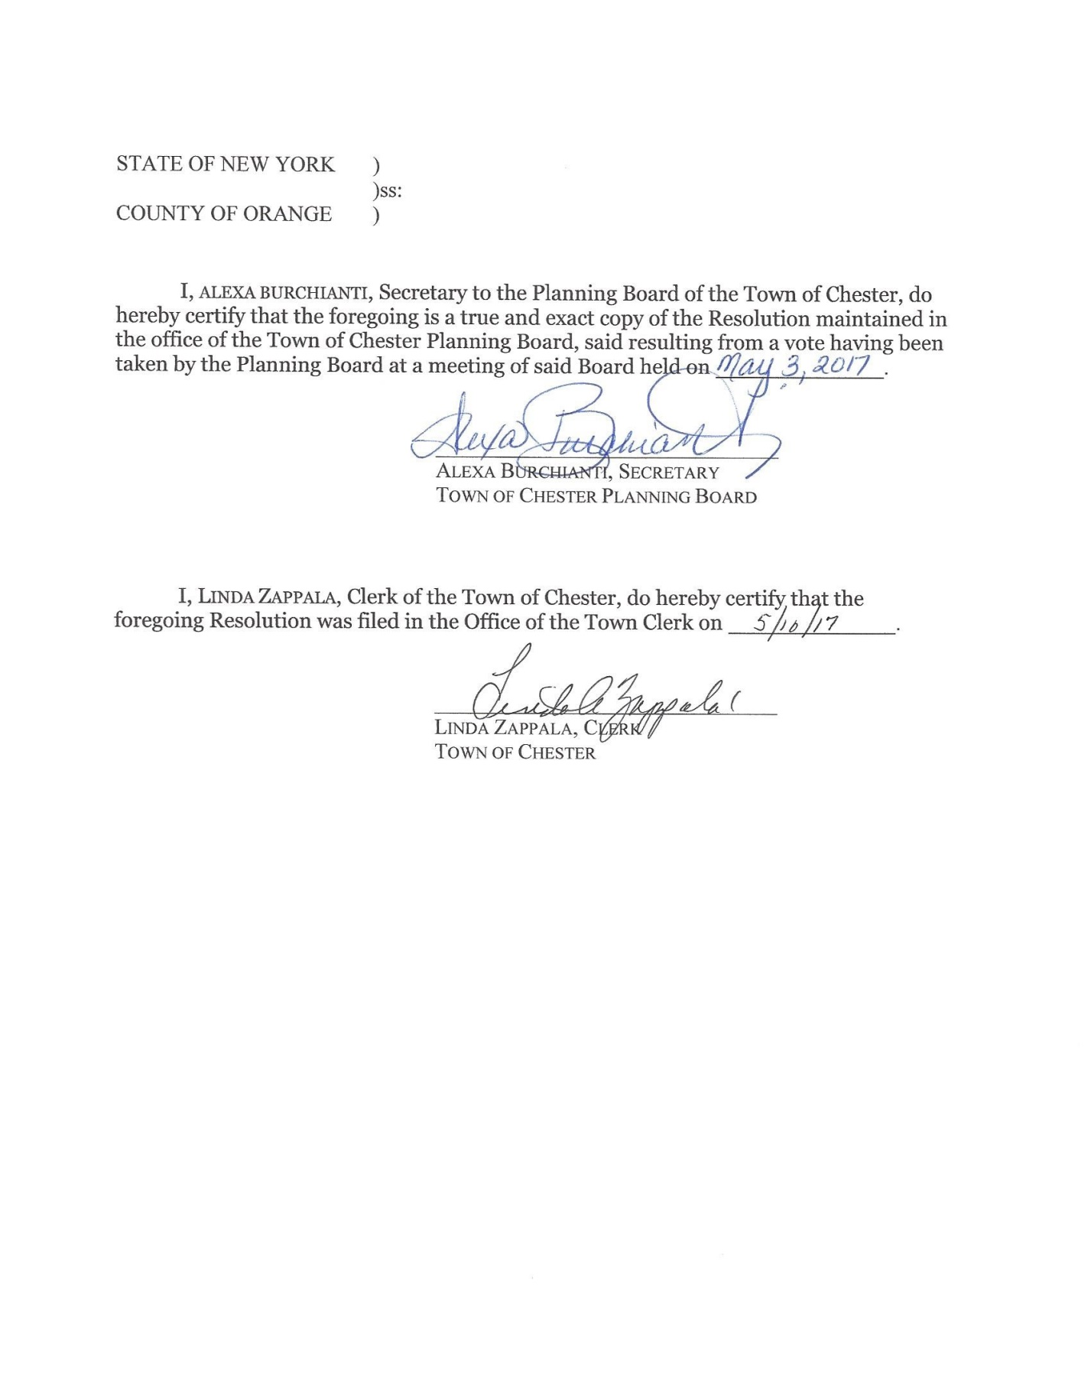

Castle Workshop – Site Plan Review
Jim Dillin for the Castle workshop. Few additional items added to plan since last meeting. One of them was the minimum setback of 30.5ft from the property line. The 2nd showed the distance 50ft to the NYS line. Note #9 was added regarding the keeping debris clear from Black Meadow Creek. Also added the sizes of the landscaping of the trees and shrubs on sheet 2.
Al Fusco: 1st comment on his letter was supposed to read “landscaping” not “land surveying” Al went on record to inform the misprint.
Will be removing 50sq yards of material which was done in the narrative, when they build the building against the buildings that were taken out.
Building rendering was pulled up on screen. Only 4 piers will be in the flood plane. Showed all 4 different views. Color of the building will be the same colors of the main Castle building. White/beige
Chairman attended the public hearing in the village for the zipline. And stated that the village and town are dependent on each other for parking. Mostly they are dependent on us. There attorney or engineer asked a question of how is this being tracked. Chairman committed to their planning board to come up with a way to formalize this. They wanted to know how many parking spot they were going to lose by the town allowing a 3200 sq ft building. All site plans should have all village and town parking on them. So we make sure we always stay that way.
Jim: Agreed to put it on the site plan that goes with the zipline and the building. They agreed to put on no changes on anything unless it goes back before both boards.
The parking count should be the same they only reconfigured the layout. The overflow is for special events only and will be done with parking attendants.
Barry : any storage by the piers? Jim: No its open. Barry would like a no parking sign by the workshop driveway entrance so stays clear for fire trucks or emergency vehicles.
Steve: Not enthused about parking in front of the workshop either. Fire hazard.
They discussed putting 3 or 4 parking spots parallel to the driveway along side of the driveway.
Al Fusco letter:
Motion to grant Negative Declaration made by Dot. Second by Jackie. Motion carried 6-0
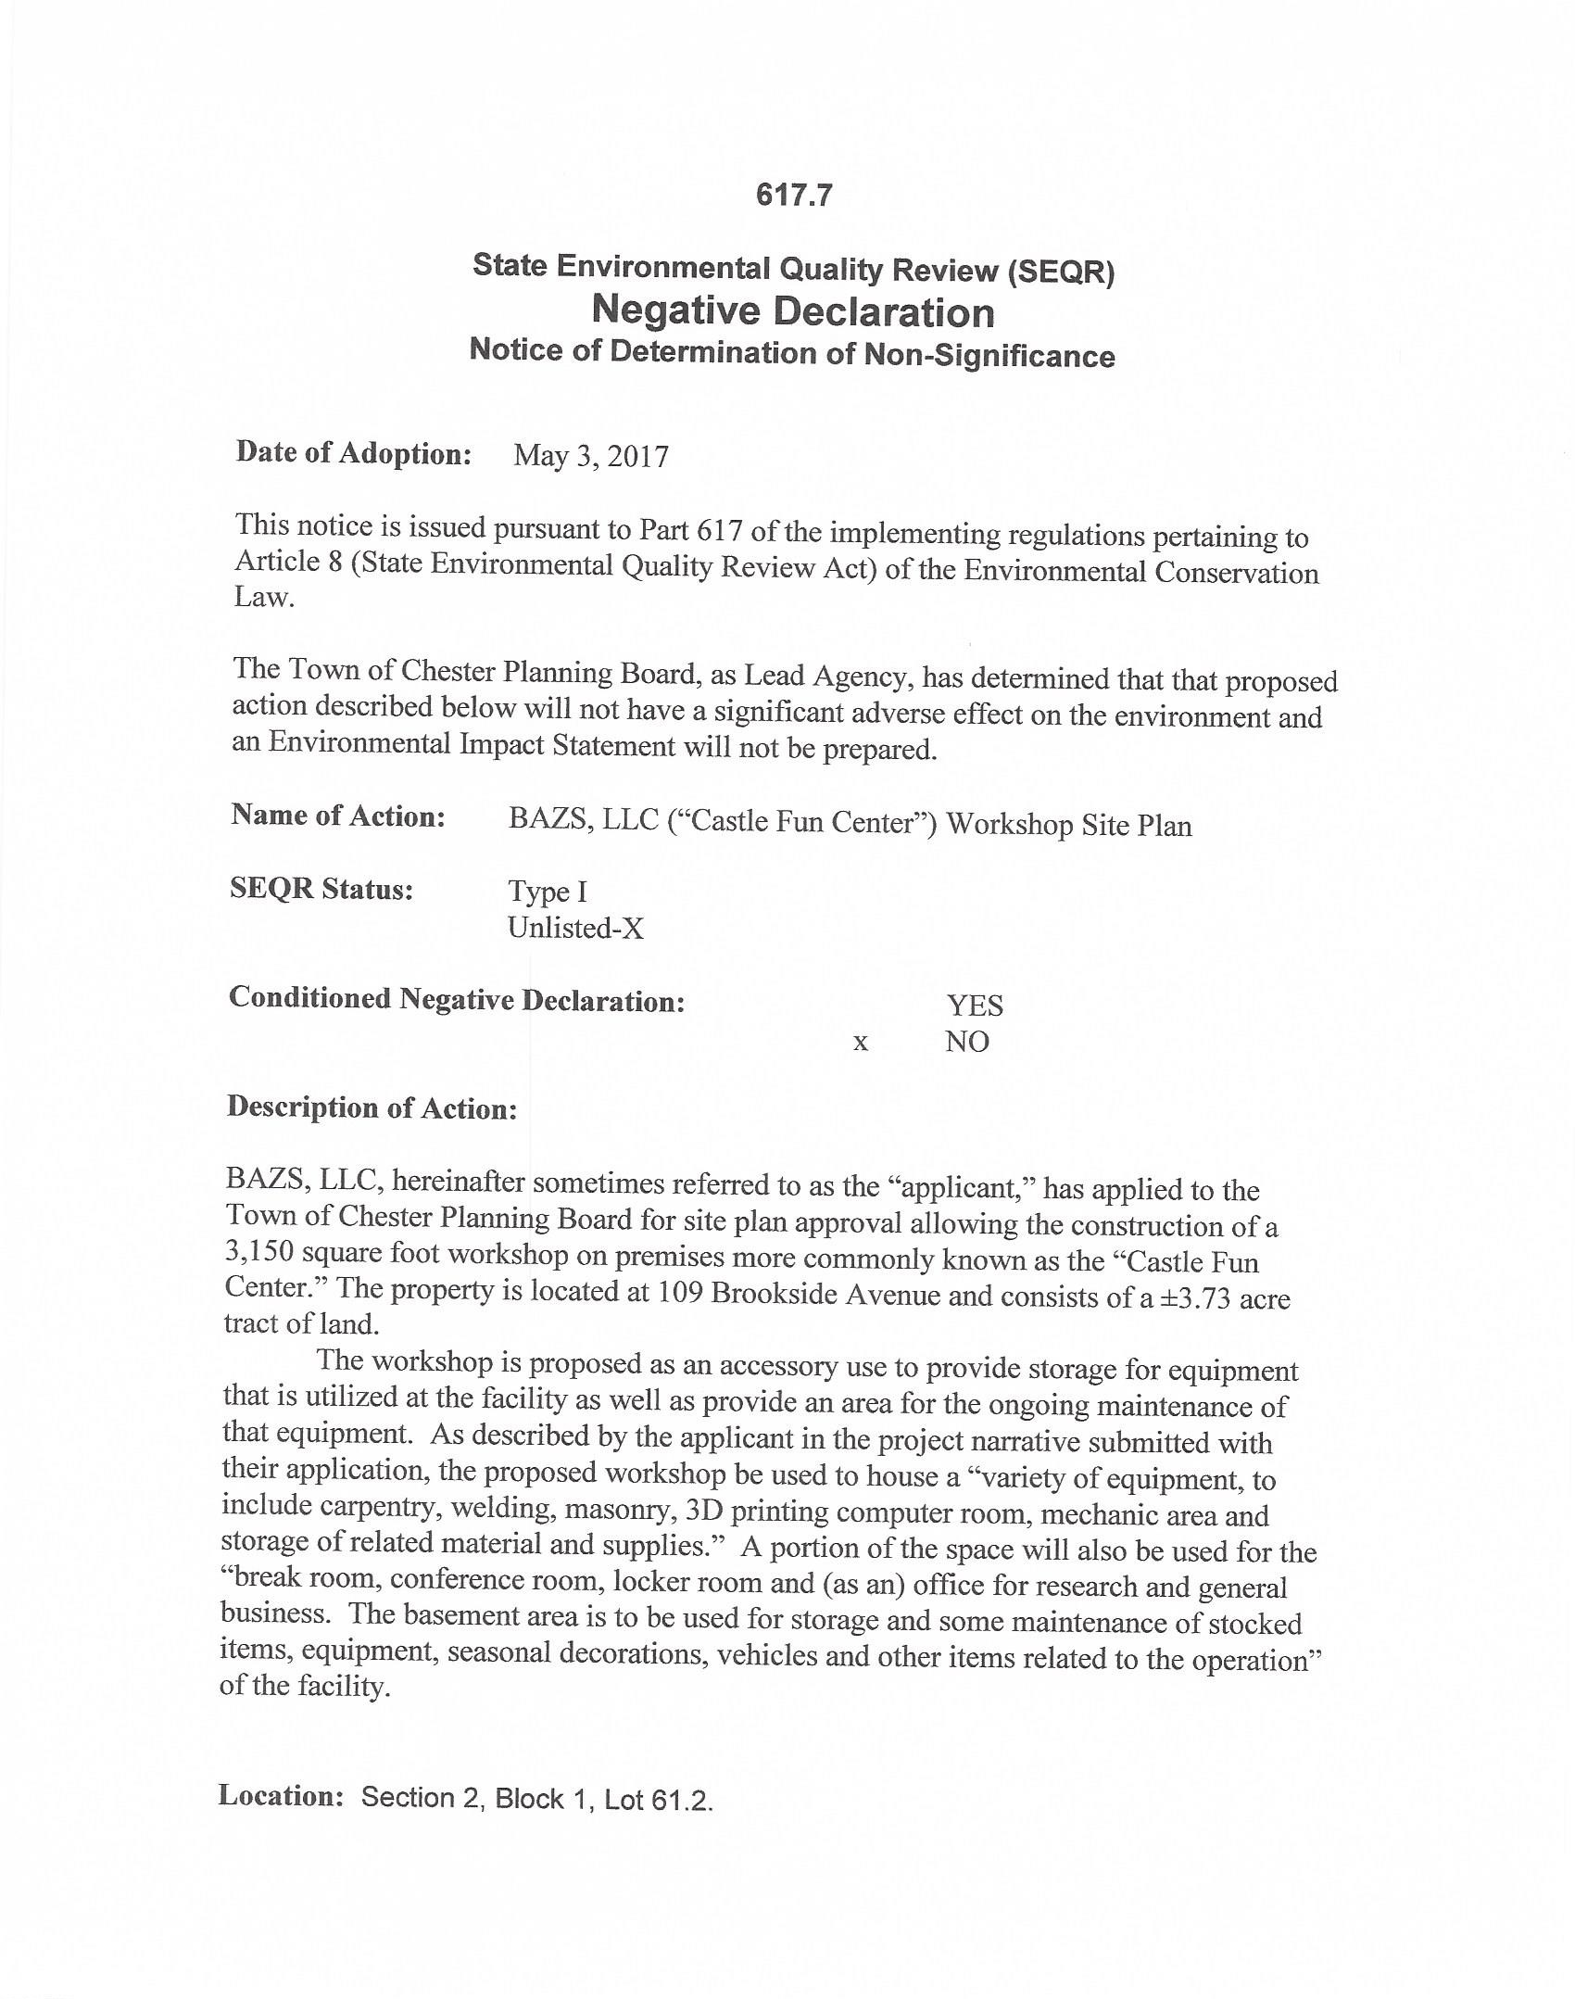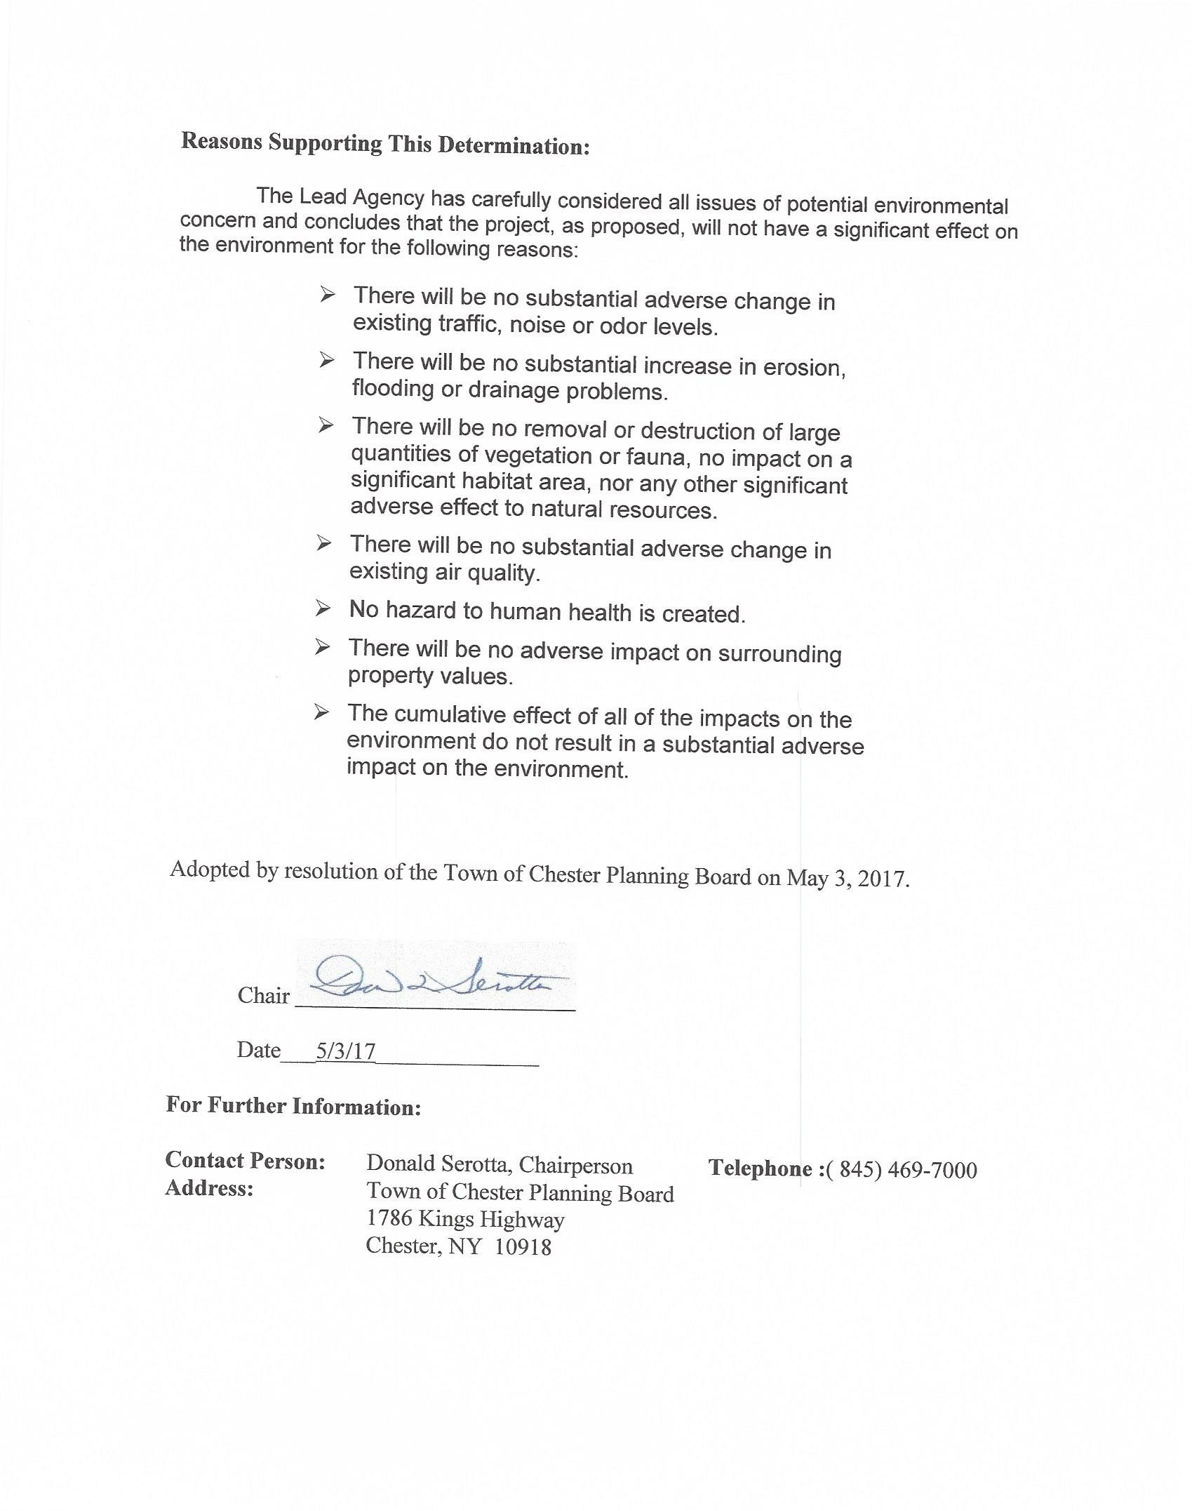
Motion to grant Conditional Final Approval. Motion made by Jackie. Second by Dot. Motion carried 6-0
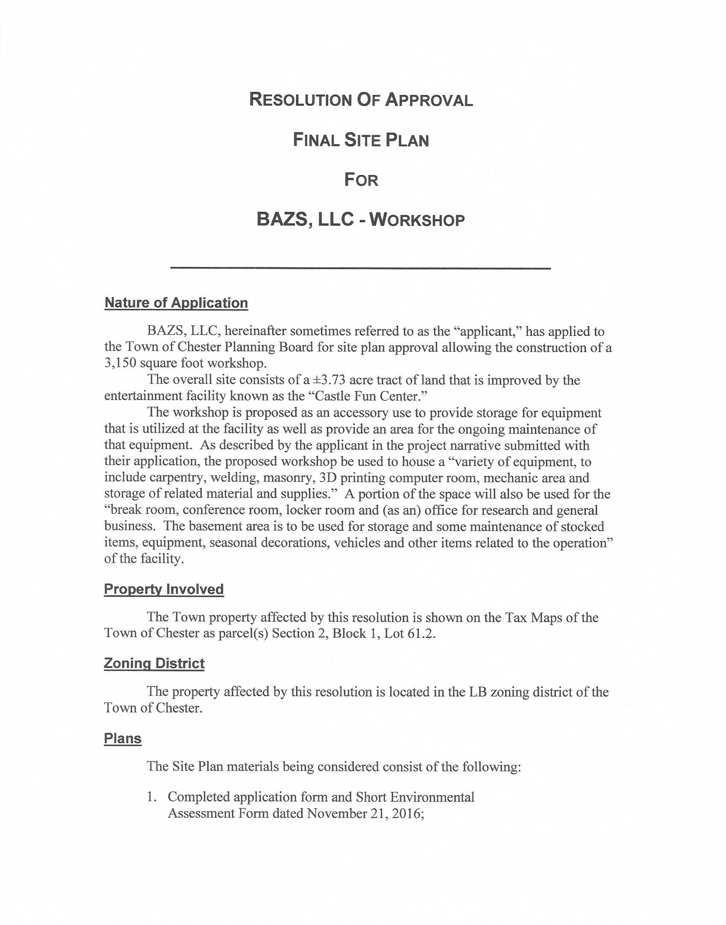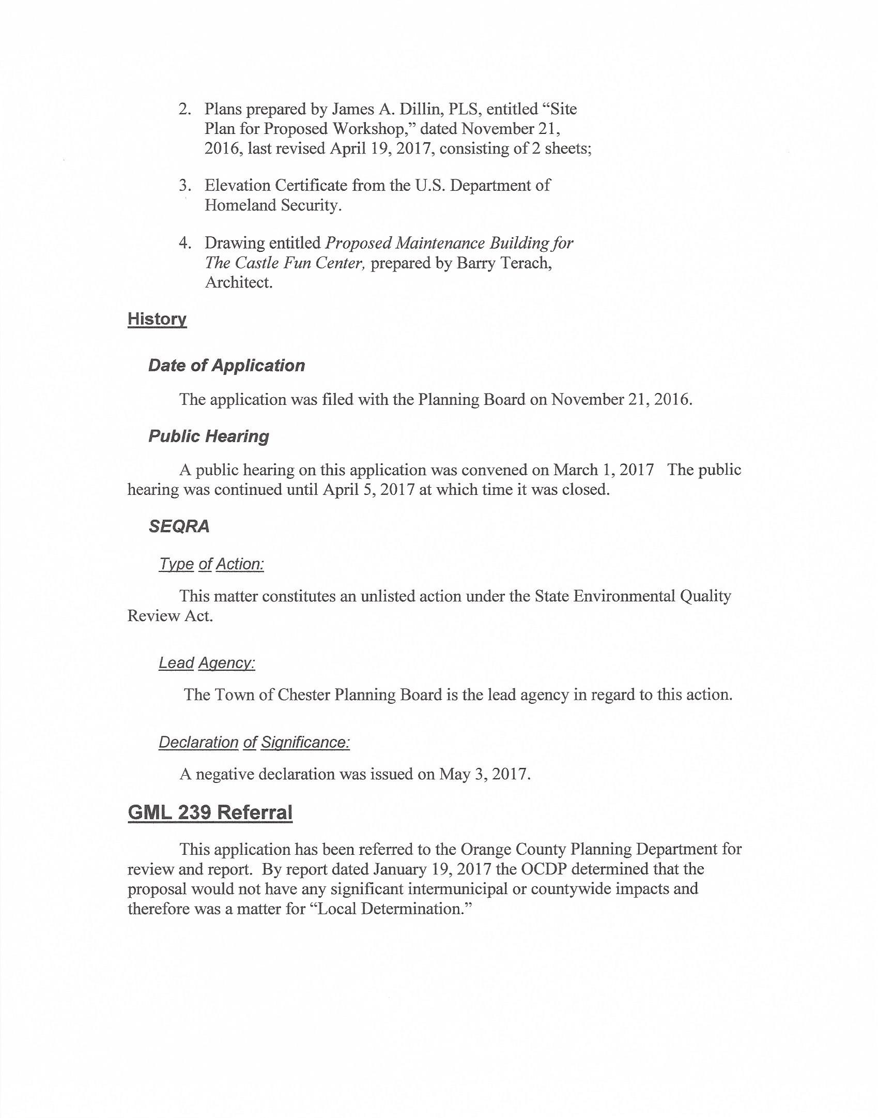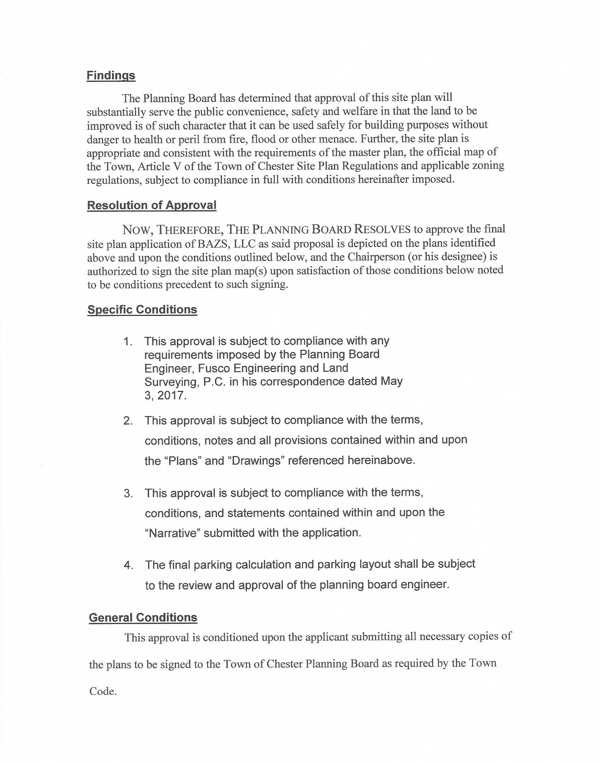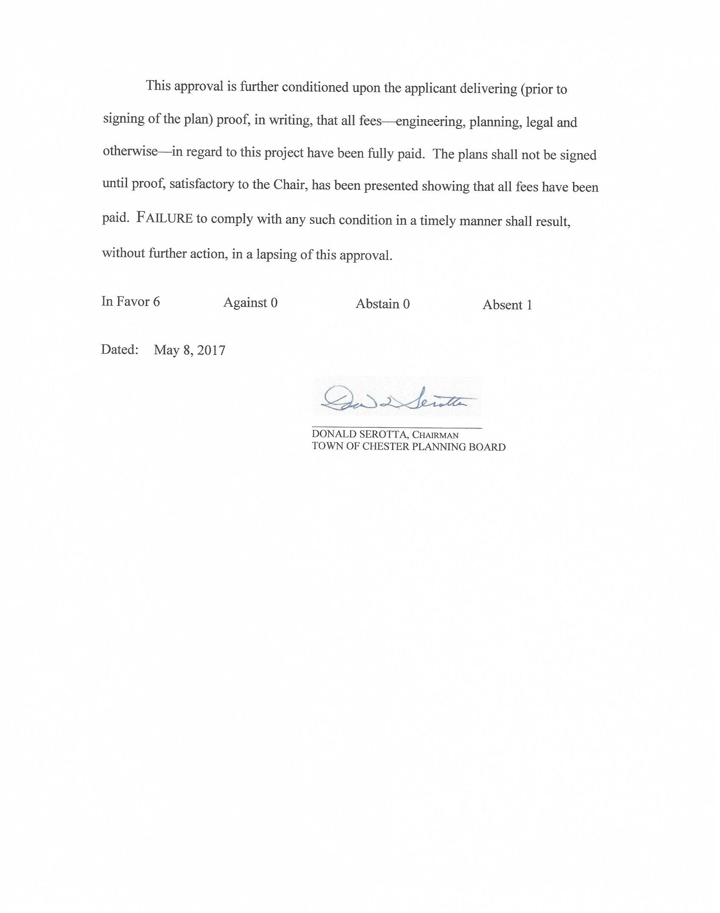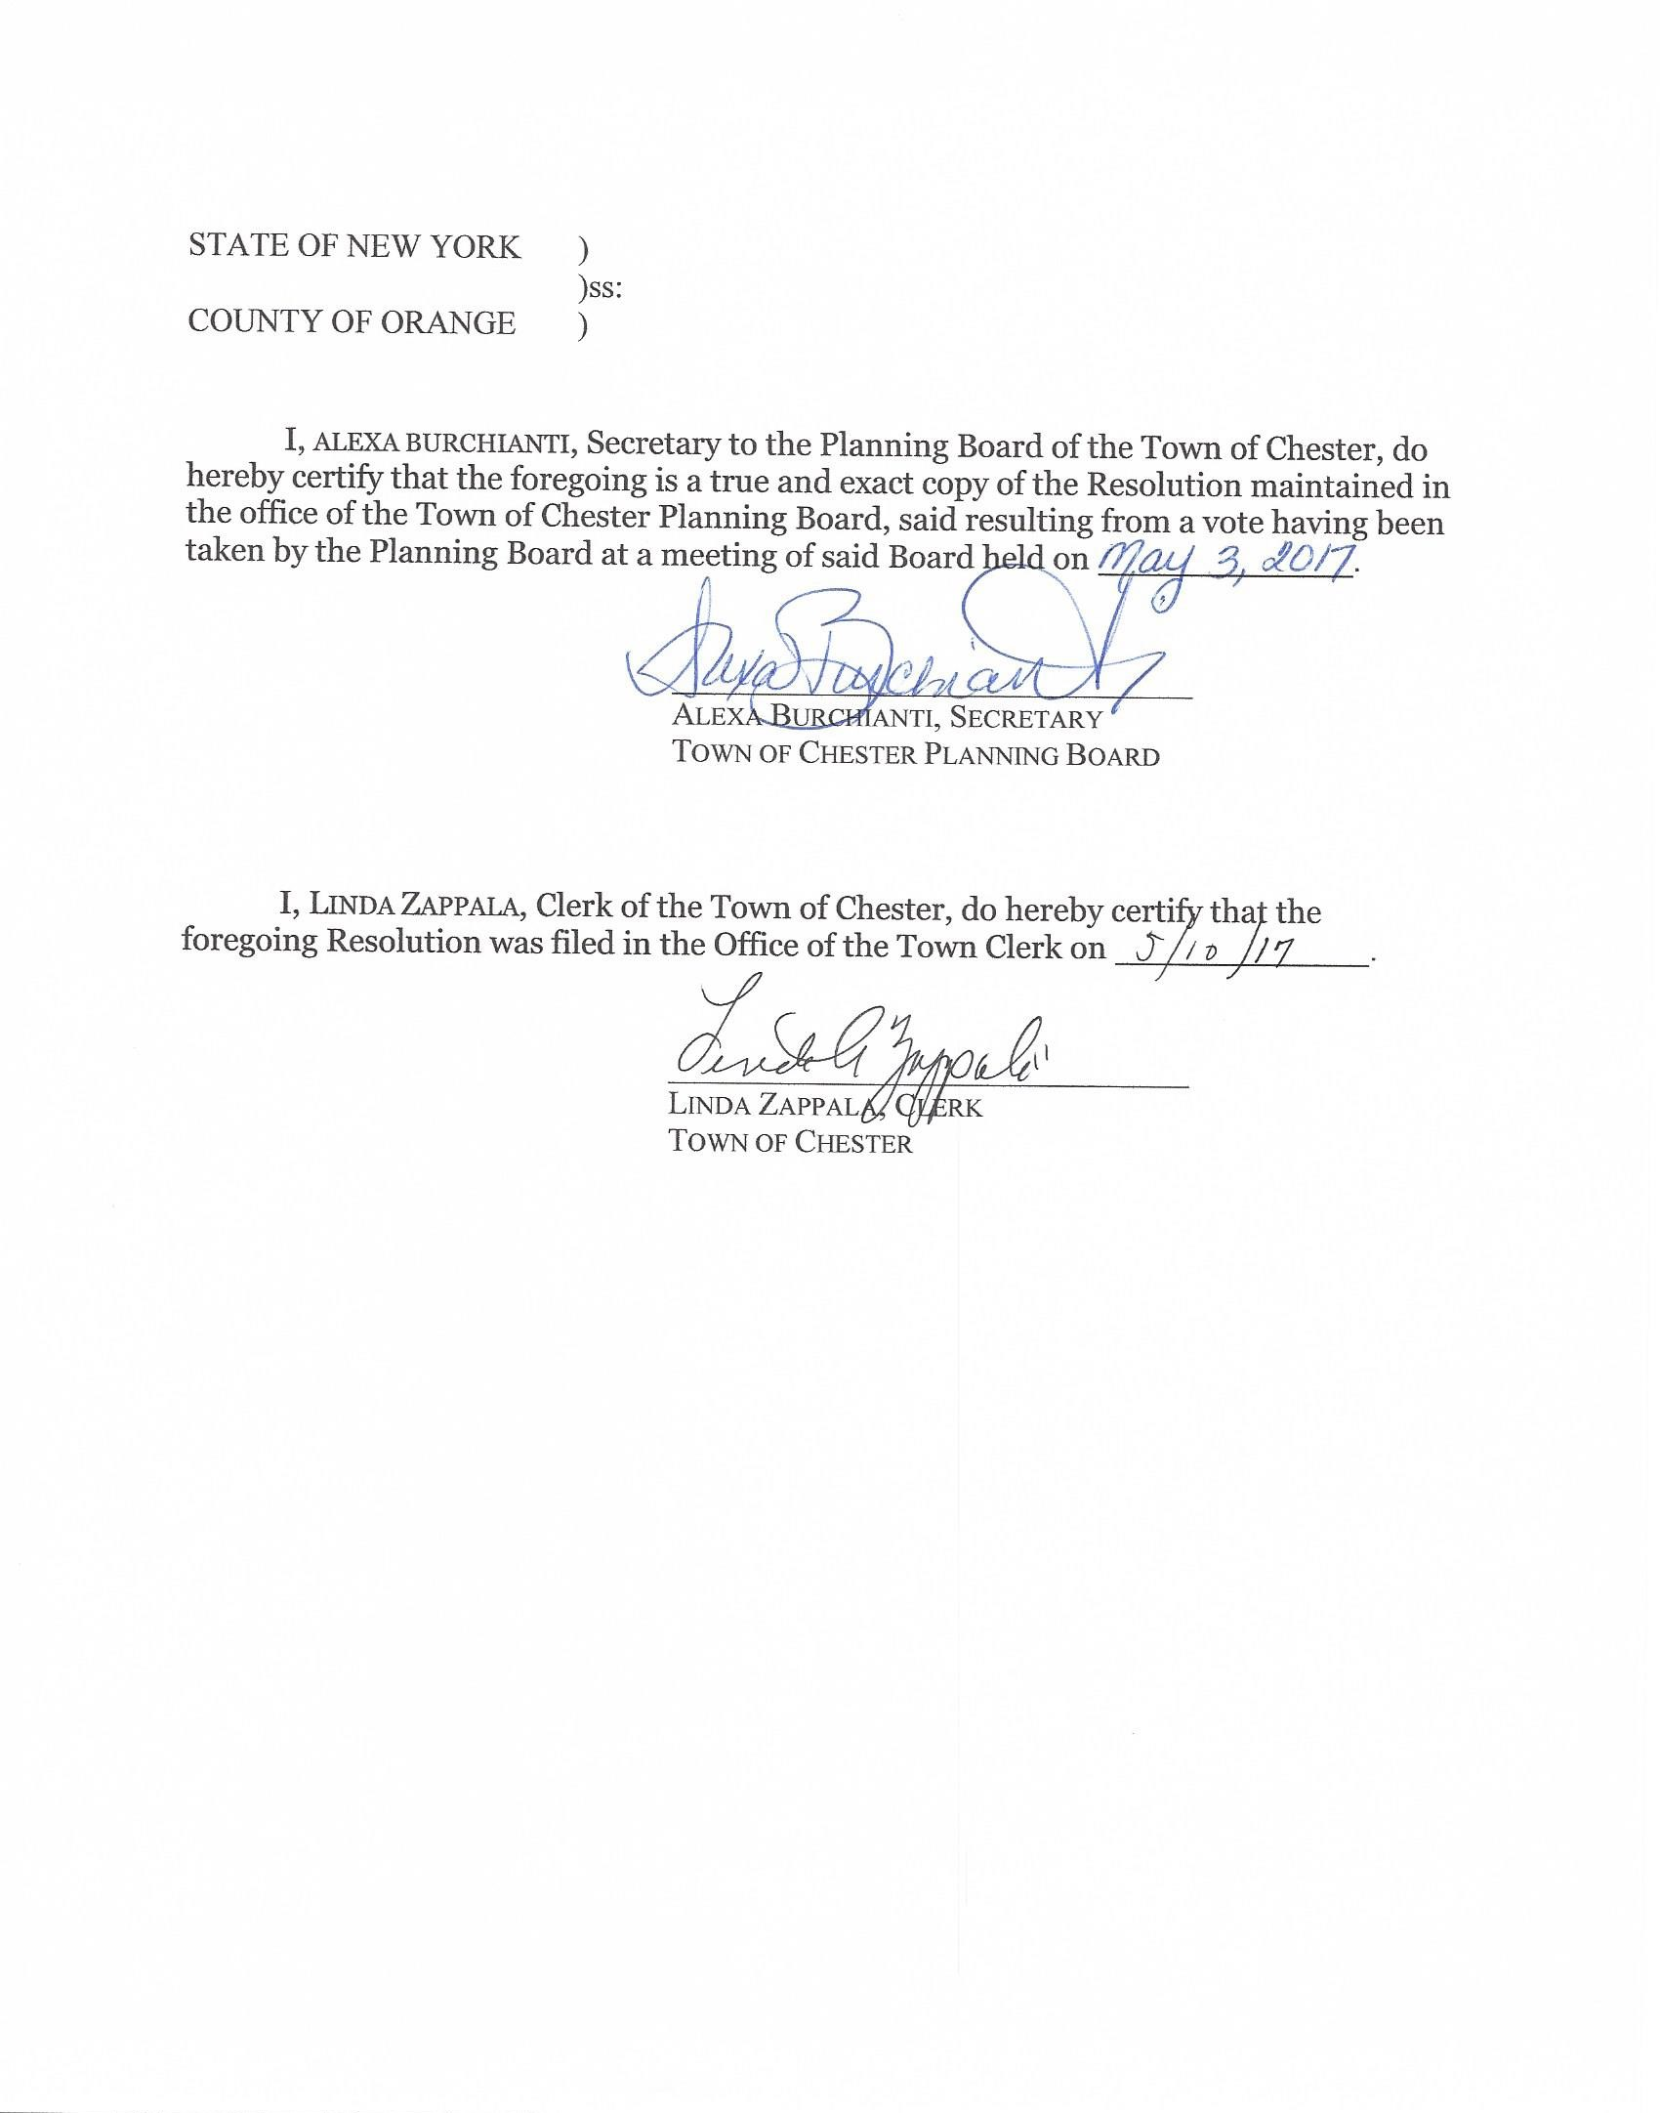

Castle Zipline – Site Plan Review
Jim Dillin for the Castle Zipline. Not many things have changed. 2nd sheet of the plan was brought up. A formal note will be put on the plan regarding the parking for both the Village and the Town. A review was made by the DEC a thorough review of the plan when it was sent out for SEQRA. Lengthy letter, they talked about fresh water wetlands, flood plain. The only thing they are really addressing is the SHPO. They made application to SHPO, waiting to hear from them. Black Meadow creek, everything they are doing, it’s a class c stream. Anything they do within 50ft is exempt; you don’t need anything unless you are building right up on the stream. Flood plain is no issue on this application because it’s just the pole.
Hours of operation: Haven’t finalized the hours yet but believes the hours will be 12am for the Castle closing hours, 10pm for any music. Believes there was a misprint on the site plan that they did for the town, they had 10:00 for shut down but it should’ve been 12. That’s why they had put 10 for any music for the event center.
NYS DOT had also sent a letter saying that they had concern about the visual impact along route 17. Then DOT sent a new letter to the Village:
Barry: They had no comment on the safety issue? Chairman: DOT doesn’t have anything to do with safety. Barry: Visual impact along 17 that’s going to impact safety? Steve: Letter says based on discussion, we just don’t know what that discussion was. Brian: The distance away from the highway, the height of the pole, they didn’t understand the project so explained to them what they were doing. Basically they told him, that a digital billboard would have more of a visual impact than the pole. Barry: Pole with a moving canopy on it? Chairman: Mark Edsall the Village engineer that night did go on record saying that he finds it strange that a small little zipline with 2 people up on top are going to cause a traffic safety, (this is his opinion) when the DOT is going to approve 3 big 48 foot flashing billboards. 2 of them in the area of the zipline.
Clif Patrick sent a letter (presentation) that was presented to the Village. Which was distributed to the Planning Board for review.
Town has no code on height of a “pole” this was sent to the ZBA for review and an area variance which the ZBA board granted.
Safety issues should be addressed to the Village.
Al Fusco letter:
Engineering on the pole and the guide wires need to be on the plans. More detiled.
Need Village approval on plans. No action taken until Village makes a decision of approval or denial.
The big question is still, is this considered outdoor recreation or an amusement park ride?
Chairman: I can give you my opinion I don’t feel it is an amusement park ride. I feel it’s an outdoor recreation.
Barry: The primary goals of the planning board is the health, education and welfare of the people of the Town of Chester, that means safety. You can argue this point from now until whenever we make the approval. There has to be a safety issues that have to be considered. Chairman: But when the NYS DOT writes a letter that says they have no safety issue are we going to hire a traffic engineer to say that we don’t agree with NYS. Barry: if this ride was 100ft off the highway I wouldn’t care. But it being 50ft off the highway I have to consider the safety of the Town and everyone that passes through it. I’m not arguing about the height. Arguing about the location and the ride itself.
Steve: I was and still am concerned about it, there are all kinds of other things that are adjacent to highways that are distracting, airplanes fly right over 94 coming into orange County Airport. Balloons for Randell airport (?) that’s eye catching. Glider operations, flags, carnival operations. Would this be more distracting than all of these things? I don’t think so, but it is a concern.
Dot: Safety issues will be going over in the Village.
Jackie: I thought the same from the first letter. I think it has been addressed.
Carl: I don’t think it is any more of an issue than illuminated signs.
Chairman: What about the outdoor recreation we might as well discuss that also
Jackie: Outdoor Rec, it’s not something you typically see at an amusement park.
Dot: Outdoor Rec. I would consider it more outdoor recreation
Steve: Amusement Park ride
Barry: I think it’s an amusement park ride, it’s a chair. There’s no effort except walking up to the chair and sitting on it.
Carl: Nope, I’m fine
Coming back with something engineered and anything from the Village. Will be back June 7th @ 7pm.
Hudson Solar – Site Plan Review
Chris Patak project manager from Hudson Solar. This is a proposed community solar project. For members of the community that can benefit from solar that doesn’t have the room on their property. Smaller footprint than the other bigger solar farms. Already has Orange & Rockland pre-approval.
4 corners have been staked out. PVC conduit has been put in place for the height of the array. Moved it a little more South on the property.
Did a test post. This particular system is mounted by driving posts not necessarily concrete footings. The machine used is comparable to what they use to install guard rails on the side of the highway. It is pounded in to a certain depth. The test post was driven 6 feet and tried to pull it out to the specifications of the manufacturer and the engineering. Wind up lift and exposure category they far exceeded it. Everything was documented. The post was left there in case anyone wanted to go and see it. Picture submitted to show no ground disturbance.
The only ground disturbance will be when they lay the conduit. Overall entire footprint is approximately 1.5 acres
Presented pictures of the site with the posts and the 4 corners staked out.
Karen Arent Landscape Architect has been asked to look at the site for landscaping for screening and visual impacts.
Fence proposed is 75” electrical code is six feet.
This will be a 239 referral will be sent to OCDP.
Motion made to grant a public hearing on June 7, 2017 @7pm. Motion made by Barry Second by Steve. Motion carried 6-0
Al Fusco letter:
Al would like a detailed Topo for the 1.4 acres. The restoration bonds need to be put in place.
Chris stated that the cost of removal including all labor and equipment would cost approximately $9,000
Chairman asked if that was based on 2017 or 2042? Chris: Based on NYSERTA they have come up with a format to remove the systems. On the State website there is a way to calculate it. It is based on future costs, but they are working off of the way the state has looked at the cost of removal. Al: Give me your calculations and the State figures and he will remove it. One thing we look at is prevailing wage. The bond is if, you don’t remove it the Town has to remove it. And the town would do it at prevailing wage. Chairman: Dave, do you and Scott get involved also? Or is that just an Al thing?
Dave: Well, I don’t know we have ever gotten that far. Chairman: We never resolved the last one. Dave: That is correct. So I will confer with Al and the Town attorney and come up with a response.
Chairman: What we try to do is protect Nancy and the Town of Chester. If you walk away and everything breaks or go bankrupt and it’s our problem now or Nancy’s. $9,000 seems cheap to me the disposal of these can’t be taken to a garbage can. I’m sure there are rules and regulations for disposal of these panels. Chris: That is true, that is the cost of just removing the system not disposing of it. Chairman: Right, so you walk away and go bankrupt now we got all these panels to dispose of. The bond is not just having guys come and remove it. We have to make sure we cover the town and that we aren’t going to be responsible for some kind of toxic waste. Both attorneys and the town have to be satisfied. We need to make sure the bond covers a 25yr period. Since that’s the life of these panels.
The easiest access is on entrance on Bellvale. That will be the access for maintenance of the array. Chairman asked if he was going to stabilize that ground the whole way in. Chris stated that they drove 2 trucks and 2 vehicles and didn’t have any issues. Barry: you would need a road cut.
Al: What they are saying is the access you need to put a 50ft long 24ft wide stabilized space, that’s rocks so you don’t travel mud out into the county road. Also block off with 2 poles and a chain. You’ll need a driveway permit from DPW.
Polled board for comments or questions:
No comments or questions

Respectfully Submitted,

Alexa Burchianti
Planning Board Secretary

